***Software Engineering Process Layer***

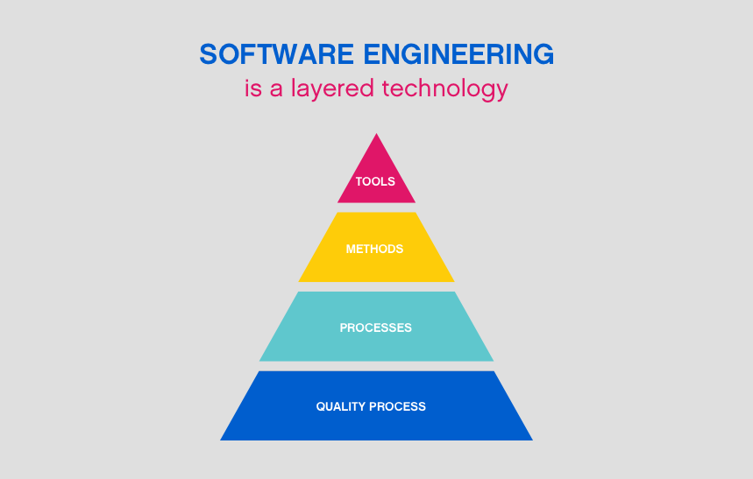

***ANDROID BASED LIVE NOTIFICATION TIME TABLE TRACKER***

***PROBLEM STATEMENT:***

Due to busy schedule, we sometimes forget our time table and have to search around for it to know which lecture we have and what our faculty is going to cover. We attempt to solve this problem using mobile notifications.

***TOOLS REQUIRED:***

1. Android Studio for Android app development.
2. Online database for storing the time table in real time.
3. Online user authentication and admin system.

***WORKFLOW DIAGRAM:***

Student/Faculty signs up on our app and select their class.

Students /Faculty receive notification for their classes and never miss any class!

Agile Model

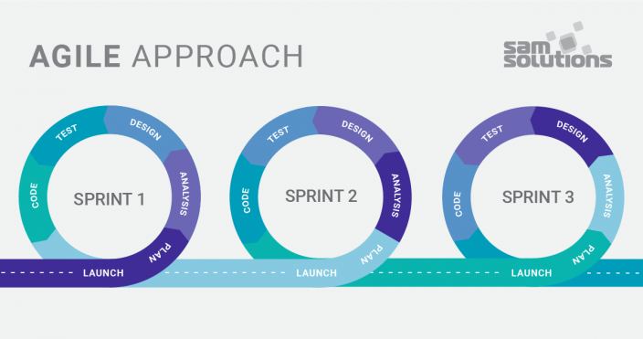

Agile model is a combination of iterative and incremental process models. It focuses on adaptability and customer satisfaction by rapid delivery of working software product. Agile Methods break the product into small incremental version. These versions are provided in iterations as an intermediate. Each iteration typically lasts from about one to three weeks. Each iteration involves a no of teams working simultaneously on various areas like −

* Planning
* Requirements Analysis
* Design
* Coding
* Unit Testing and
* Acceptance Testing

At the end of the iteration , a working product is displayed to the customer and important stakeholders. In this way we get an end of all iteration a final version is produced according to customer requirement for a release. Agile model believes that every project needs to be handled differently and the existing methods need to be tailored to best suit the project requirements. It is considered to be quiet flexible and adaptable.

The most popular Agile methods include Rational Unified Process (1994), Scrum (1995), Crystal Clear, Extreme Programming (1996), Adaptive Software Development, Feature Driven Development, and Dynamic Systems Development Method (DSDM) (1995). These are now collectively referred to as **Agile Methodologies**, after the Agile Manifesto was published in 2001.

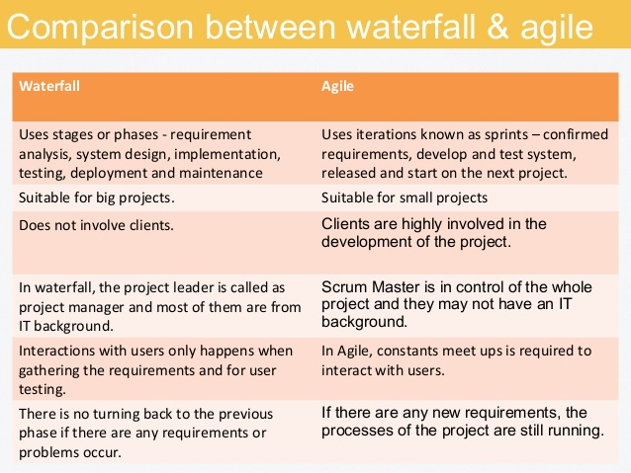

Due to these reasons we can say that agile model is better than waterfall model.

